Paediatric Referral Refinement Scheme (PRR)
August 2021
There are 6 phases of the service:
- Input of details by screener
- Referral module for POS admin team to allocate to practice
- Acceptance or rejection by practice
- 1st appointment
- 6 week phone check (if follow-up required)
- 12-16 week check (if follow-up required)

All children in reception will have visual screening performed by the HCP. The possible outcomes are:
1 | Discharged | Vision is 0.200 or better in both eyes
2 | Sent to PRR | Vision is equal to or better than 0.400 with less than 0.200 difference between the eyes  (In Lewisham if a px has RE 0.1 and LE 0.3 or vice versa, refer to PRR)
3 | Referred direct to HES/Orthoptic team | 0.425 or worse and equal to more than 0.200 difference between the eyes

Only the children in group 2 will have their details uploaded to Pharmoutcomes
PharmOutcomes uses Personal Demographic Service (PDS) – much quicker to input patient details and will also populate the GP
This will highlight any children that are registered with a GP out of area – areas involved are Lambeth, Southwark, Lewisham, Bexley, Bromley, and Greenwich.
Children registered with a GP outside this area if doesn’t meet the criteria will be referred direct to the HES Orthoptists. (This is anticipated to be a low number)
This is what the registration page will look like along with the info off the HCP on VA and any other relevant info they may wish to add.

- Input of details by screener

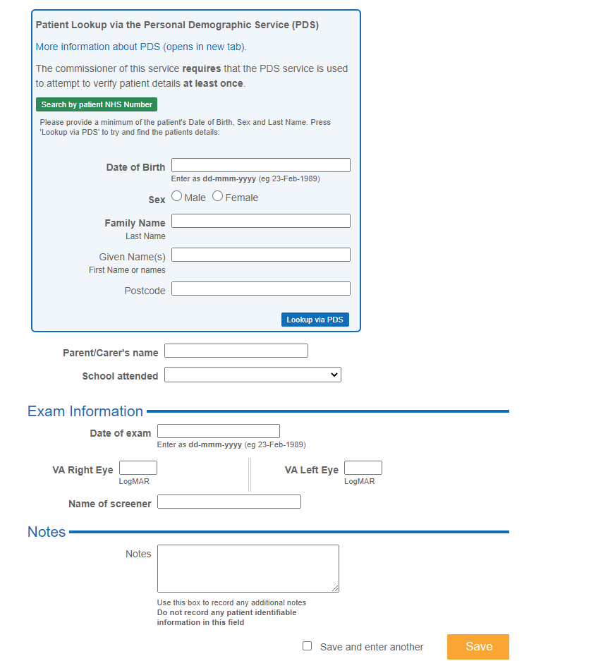
This information will then lead into the module for POS
2) Referral module for POS admin team to allocate to practice

The details will be accessed by POS within Pharmoutcomes.
POS will contact the patient and explain the service and px will choose a practice. POS will be able to track the progress of patients throughout the service using a specialist report PharmOutcomes will build.
3) Acceptance or rejection by practice

The referral is then received by the practice (via a platform on PharmOutcomes), hopefully accepted and the patient is contacted to arrange an appointment preferably within 4 weeks subject to patient availability.

The practice can log all attempts made to contact the patient – however if they continue to fail, PharmOutcomes will record this and as part of failsafe the referral will go back to POS.

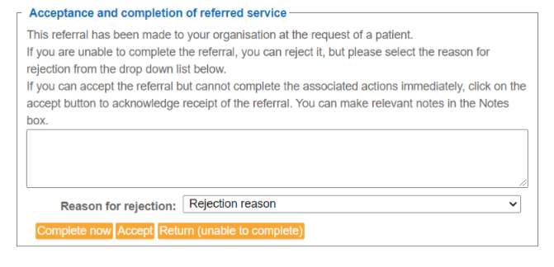

Once contact has been made and an appointment has been made the parent/carer can also be emailed further advice about the appointment and what to expect. (At end)

4) 1st appointment with community optometrist

Paediatric Eye Examination with Optometrist
The form has been designed that if the Optometrist wishes to use this form as their GOS claim they can – however if they choose not to, they must complete the mandatory fields which will provide the requested audit data.
All the info is within this part and all the possible outcomes.
At top of the exam the info taken by the HCP will be pulled across:
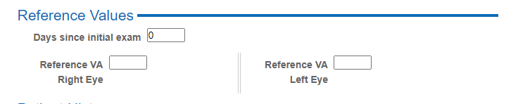

Patient History:
Optometrists are expected to include any relevant GH/Meds/Ocular HX that may be beneficial to any onward referral – additional info such as birth info (premature etc) would be helpful. This can be used to generate any onward referral and to notify the GP of the outcomes.
There is a separate mandatory box about Squint/Amblyopia
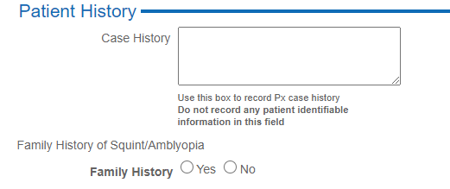
Anything in bold on Pharmoutcomes is mandatory:
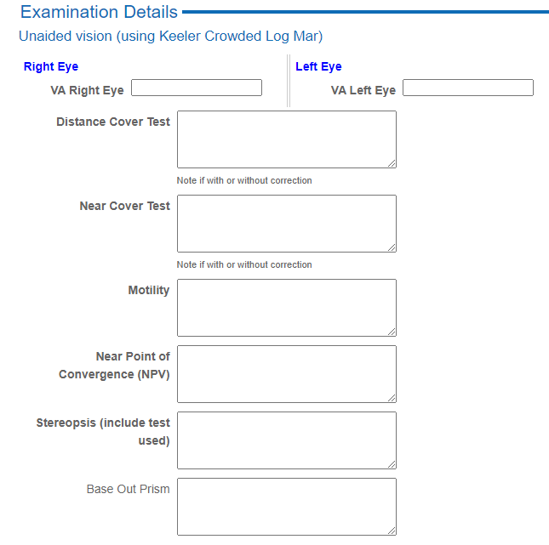

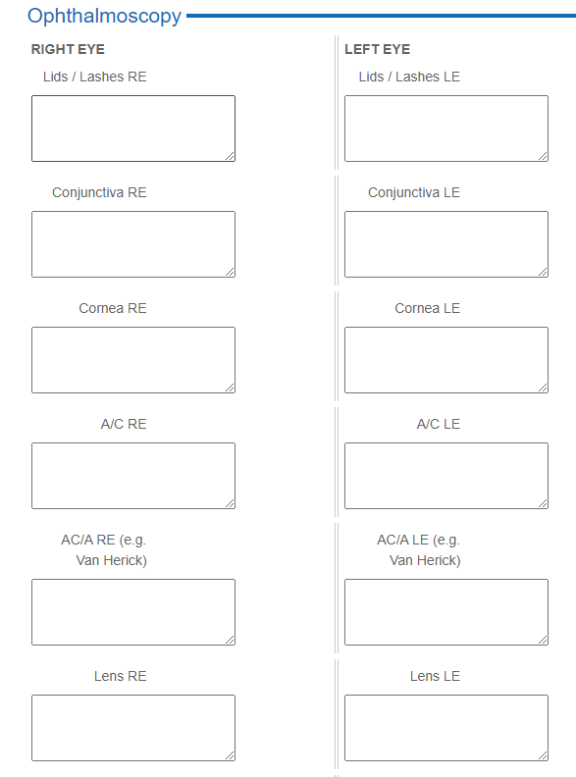
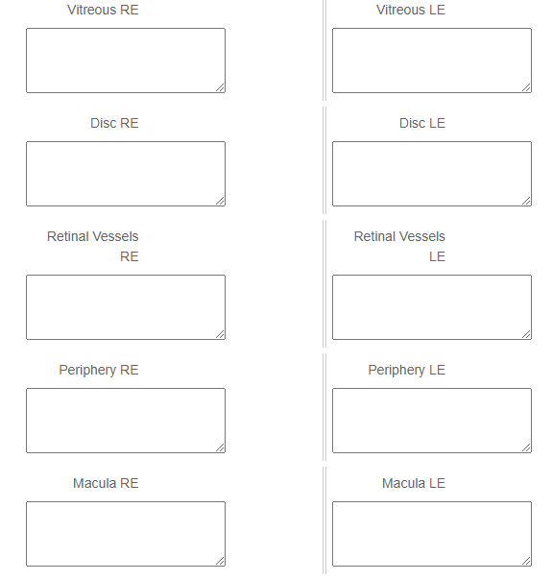

All children are to be cyclo’d unless there is a mitigating circumstance – if not dilated you may not be paid. If on a quick ret you believe a child to be myopic, they still must be dilated.
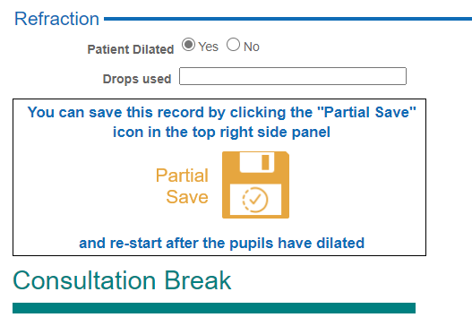
At this point you can save and return to the patient post dilation.

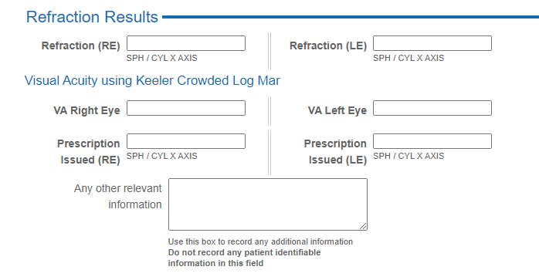
Once the Optom has established any prescription to be prescribed and the VA, they can use the decision-making tool kit to guide them on the next steps:
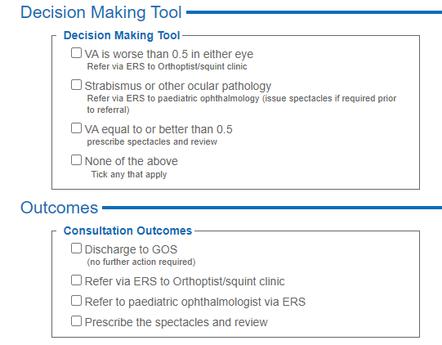
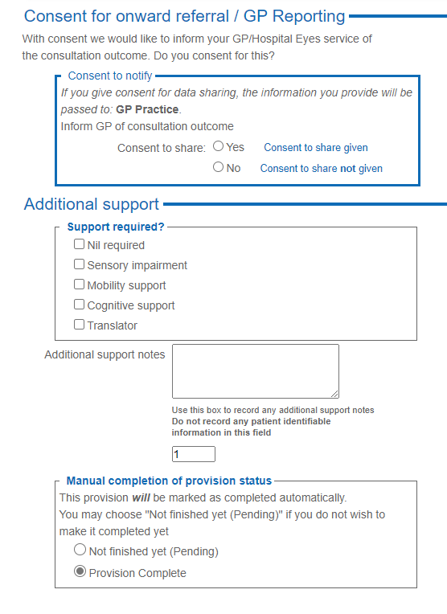
- At this point if a referral is required it can be generated and a notification will be sent to the GP.
- All onward referrals are to the HES via ERS.
- Follow up appt is booked – this is for children who have VA equal to or better than 0.5 and were prescribed spectacles.
5) 6 week post check via telephone:
This is to check the px is wearing the spectacles – if there are any issues px can be brought back to the practice sooner – spec adjustments etc
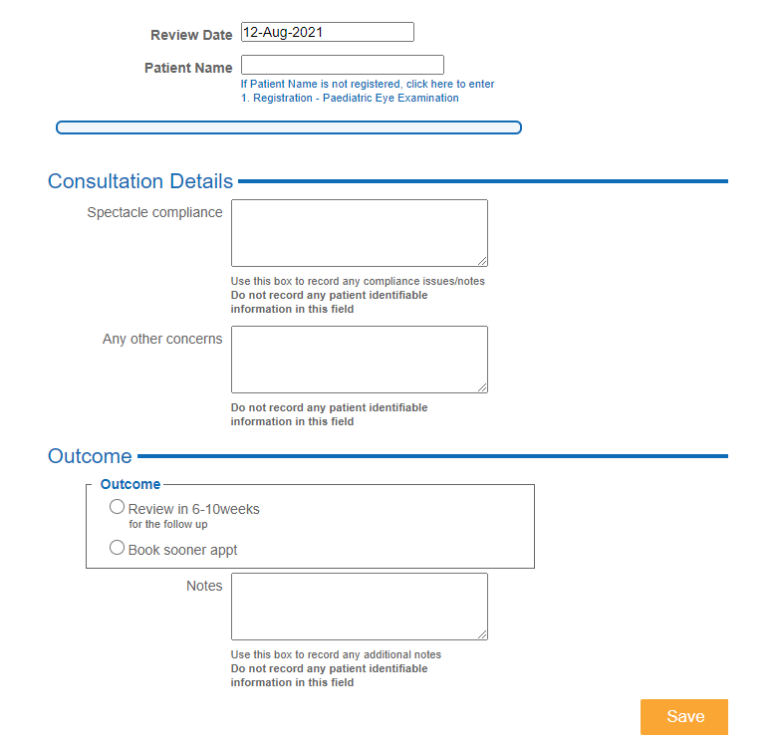

6) 12-16 week post VA check:
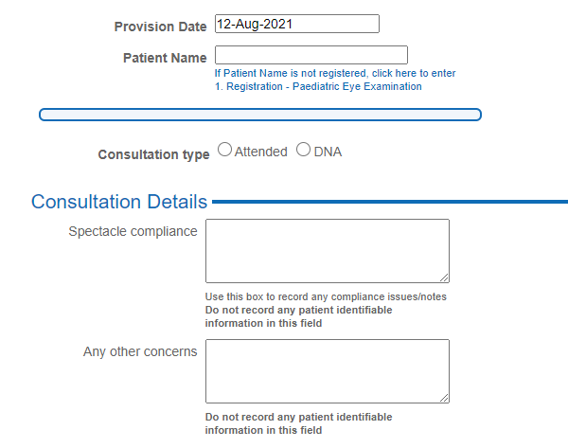

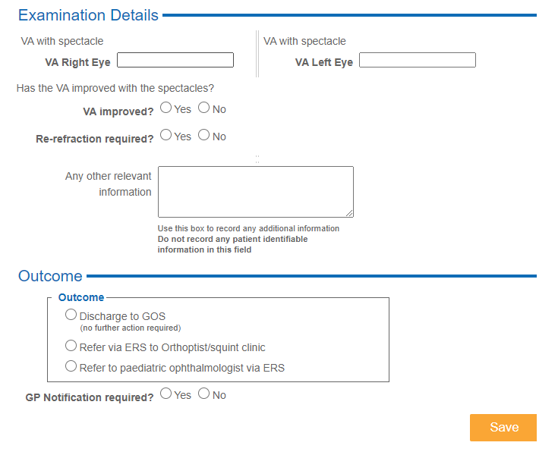

If after this appt VA is improving patient will be referred into GOS and no further action required.
If no improvement, refraction will be checked and if no VA improvement px will be referred to orthoptists at HES.
If patient fails to attend, they will be contacted to make another appt but if fail again gets sent back to POS.

Keeler LogMAR Visual acuity
As you may have read in the above, the method used to record VA MUST be Keeler Crowded LogMar acuity. This is in line with the national screening program and also various studies (link below) show that crowded LogMAR gives more accurate results than Kays for example.
The Keeler LogMAR uses the letters X V O H U Y for all screening, and this is to be replicated in this service.
You can set up Thomson test chart to do this for the PRR patients (website link below)
You may also use the Keeler flip charts
If you aren’t used to recording VA with logmar there is a link below.
If you see a child who does not know their letters, then you need to try and record their VA as best as possible – if this required Kay’s crowded then please make sure this is recorded on the notes. Please note VA is an integral part of the audit and needs to be as accurate as you can get.

Useful links
Child vision screening - GOV.UK (www.gov.uk)
Screening competencies - GOV.UK (www.gov.uk)
Keeler logmar charts LogMAR Crowded test | Diagnostic, Magnification, Optical, Healthcare (keeler.co.uk)
Crowded letter and crowded picture logMAR acuity in children with amblyopia: a quantitative comparison | British Journal of Ophthalmology (bmj.com)
Snellen and LogMAR acuity testing - The Royal College of Ophthalmologists (rcophth.ac.uk)
LogMAR chart - Wikipedia

