Referral Essentials

Elements that make a good referral
All referrals

Px details
Full name | Date of Birth | NHS number | GP details
Address | Telephone | Email | Additional needs

Referrer details
Optom Name | GOC number
Practice Name | Address | Telephone | Email

Referral summary
Reason for referral | Clinic type | Urgency | HES site preferred
Summary statement for GP – e.g. notification only or action required by GP

General Info
POH | Px Rx | V or VA | Pinhole if VA poor
GH | Meds | Allergies | FHx

Select referrals

Specifics by area
Glaucoma:  - IOP (applanation)  - VF (attached)  - AC angle  - Disc assessment  - Disc images/OCT (if poss)  - Risk factors  - Refraction | Cataract:  - VA/pinhole  - Rx  - Previous Rx/VA if available  - Any notable Rx shift  - Symptoms/QoL  - Dilated fundoscopy  - Refractive aims | Suspect swollen discs:  - Symptoms  - VA  - Pupils  - Monocular colour vision  - OMB/motility  - VF  - Disc assessment
Adult Cornea:  - Rx  - VA  - Corneal description  - Keratometry/topography if suspect kerataconnus  - If encroaching visual axis  - CL Hx/POH | Macula:  - VA and pinhole if poor  - Symptoms  - Amsler  - Macular description  - Images/OCT | Paeds:  - VA  - Refraction (cyclo if poss)  - If suspect squint then CT, motility, stereopsis, corneal reflexes  - Birth/Development & FHx

Specifics by test

Visual Acuity
Unaided (if applicable) | Spec Rx | VA
Pinhole if poor VA | Previous Rx if aids referral

IOP
IOP reading | Instrument used | Time of day

Fields
Test performed | Description of findings | Copy attached

Disc
vCD ratio | Disc size | NRR description
Colour | Cup depth | Vessel concerns

Macula
Description | Drusen | Pigment
Haemorrhages | Fluid/exudate | Amsler

Vitreous
Tobacco dust | Weiss ring | Asteroid hyalosis
Posterior vitreous face | VMA/VMT | Lattice/peri degeneration

Retina
Physiological variations | Tears/holes | Pigmentation
Drusen | Diabetic/Vascular | Other chorio/retinopathy

Lids/lashes
Lid malposition | Blepharitis | Lumps/bumps

Anterior Eye
Cornea | Conjunctiva | Tear film
Anterior chamber | Iris | Lens

Any Lesion
Location | Size | Colour
Morphology | Edges | Associations

Triage and History Taking Considerations
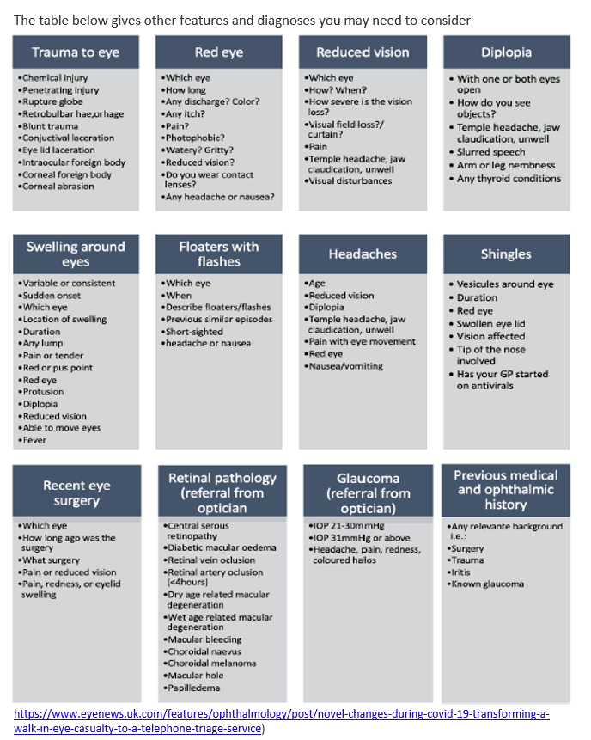

Management Considerations

Is it imminently life or sight threatening?
- Yes – Emergency to EyeCas or A&E
- No – next question

Is urgent care required?
- Yes – refer to EyeCas (ophthalmic) or A&E/GP (systemic)
- No – next question

Is there sufficient justification for referral? (see referral criteria)
- Yes – refer routinely, identify relevant clinic/HES, attach all necessary information
- No – consider monitoring/discharge

Note:
- There are risks and benefits to any intervention
- Treatment funding under NHS follow stringent guidelines
- Not all treatments are funded by NHS

Final Referral Checklist

- Correct px details ?
- Is referral required ?
- Correct clinic ?
- Correct HES choice ?
- Correct level of urgency ?
- Have you clearly identified your reason for referral ?
- Have you provided all relevant evidence for your referral ?
- Have you attached all necessary attachments

