Dear Primary Care Clinician

I am contacting you with information about the waiting times for new appointments at the hospital ophthalmology services of King’s College Hospital NHS Foundation Trust (KCH) and Guys and St Thomas’ NHS Foundation Trust (GSTT).

**Please can you provide patients with this information when discussing their referral so they can make an informed choice based on the waiting times for an appointment in South East London.**

KCH and GSTT are working closely together in order to equalise waiting times and ensure equity of access for patients. As you can see in the table below there are differences in the waiting times across the sites in South East London which patients may not be aware of. This is something we are trying to address and your help with directing patients to the shortest wait where appropriate will help achieve this aim.

**Average weeks wait for a new appointment at hospital ophthalmology services: (Please allow a 1-2 week variance in the below waiting times, as they were pulled on the 06 December and may have changed).**

|  |  |  |  |  |
| --- | --- | --- | --- | --- |
| **Ophthalmology specialty** | **GSTT – St Thomas’s (weeks wait)** | **KCH - Denmark Hill (weeks wait)** | **KCH – Queen Mary’s Sidcup (weeks wait)** | **KCH – Orpington (weeks wait)** |
| Cataract | 18 | 22 | 39 | 20 |
| Cornea | 13 | 36 | 19 | 9 (limited service) |
| Medical Retina | Waiting times at QMS & Orpington for wet AMD are extremely long please consider sending patient to the other sites | | | |
| Glaucoma | 20 | 11 | 12 | No service at this site |
| Laser (YAG Capsulotomy) | 34 | 20 | 48 | 23 |
| Oculoplastics | 7 | 14 | 19 | No service at this site |
| Squint / Ocular Motility | 8 | 13 | 52+ | No service at this site |
| Vitreoretinal | 18 | 5 | 21 | No service at this site |
| Paediatric ophthalmology | 8 | 36 | 11 | No service at this site |

The map below shows the geographical locations of the four sites, please ensure this information is provided to patients along with the waiting times so they are aware of where they can access services in South East London.

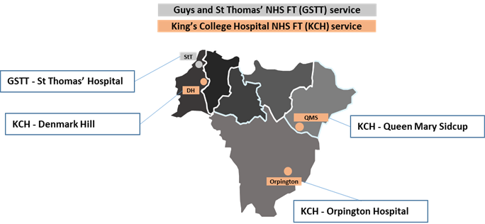

This communication will be sent to you on a monthly basis going forward with updated waiting time information.